# JavaScript UI & DOM – Practical Exam

17 June 2014

# Task 1

## Task

Given the HTML (index.html) write JavaScript function ***createImagesPreviewer(selector, items)*** in file scripts.js.

The function accepts two parameters:

* **Selector** – the selector of the DOM element, where the previewer must be generated in. It can be any CSS3 selector ('#id', '.class', 'NODE_NAME')
* **Items** – an array of objects. Every object in the array has **two mandatory properties** – **title** and **url**. Title is the title of the image, and url is a path to the image (JPG/PNG).

### The execution of the ***createImagesPreviewer(selector, items)*** function should result as follows:

* 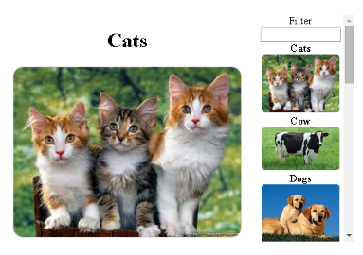All images from the items collection must be displayed on the right
  + With their title above them
* Above the images on the right, there must be a filter box
  + For filtering the images
* The first item from the items collection should be displayed bigger on the left
  + With its title on top

### C:\Dropbox\Telerik Academy\js-part2\2014\Exams\17-June\Task 1\task-files\task-images\cow-hovered.pngImages in the list (on the right) have some properties:

* When *hovered*
  + They should change their background color
* When *unhovered*
  + 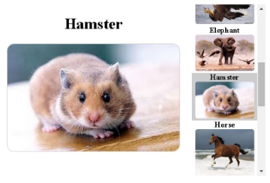They should return to their default background color
* When *clicked*
  + The bigger image and its title (on the left) are replaced with the clicked image on the right

### C:\Dropbox\Telerik Academy\js-part2\2014\Exams\17-June\Task 1\task-files\task-images\text-in-filter.pngThe filter should provide functionality for filtering the images on the list of images (on the right)

* When the *text in the box changes*
  + The list of images should be **filtered** only to those that have a title containing the pattern
* When the *text in the box is empty*
  + **All images** should be visible

**You can find more images to help you understand the task in the 'result' folder.**

## Constraints:

* You are allowed only to edit the contents of the file "scripts.js"
* You are NOT allowed to edit the contents of the HTML and/or the CSS files

## Files to Submit

When ready send all files in “task-files” directory as a single zip file.